SPATIOTEMPORAL MODELLING & AUTOMATED *IN-SITU* SENSORS TO MONITOR HARMFUL ALGAL BLOOMS (HABS)

***Case Study Lake Victoria***

**by**

Okomo Jacob Okello

*Project report submitted to the department of Geomatic Engineering and Geospatial Information Systems degree of Bachelor of Science in Geospatial Information Sciences (GIS), 2021.*



**Department of Geomatic Engineering and Geospatial Information Systems (GEGIS)**

DECLARATION

*I declare that this project is my own work and has not been submitted by anybody else in any other university for the award of any degree to the best of my knowledge.*

Sign………………………………… Date………………………………………...

Jacob Okello Okomo

ENC222-0149/2017

Department of Geomatic Engineering and Geospatial Information Systems (GEGIS)

Jomo Kenyatta University of Agriculture and Technology

CERTIFICATION

This project has been submitted for examination with my approval as the candidate’s supervisor.

Sign……………………………. Date ………………………………………………

Dr. Eunice Nduati

Senior Lecturer, GEGIS

Department of Geomatic Engineering and Geospatial Information Systems (GEGIS)

©GEGIS 2021

# Acknowledgements

I sincerely thank Google Earth Engine and United States Geological Survey (USGS) for the provision of Satellite Remote sensing images, particularly Landsat 8 image collection that came in handy for this project realization.

Free software provision by QGIS, Python, R and RStudio, RaspberryPi, Fritzing and KiCAD are highly appreciated.

Sincere gratitude is as well sent to Kenya Marine and Fisheries Research Institute (KMFRI) for providing a tone of information that are directly in line with this project.

My sincere gratitude to my very supportive supervisor Dr. Eunice for her continued advice, support and motivation towards full realization of research objective 1, 2 and 3 at the time of this submission. I would as well like to acknowledge the efforts of my lecturers who directly impacted me with knowledge in various aspects and skills that have played key roles in my project. To you all, may you be blessed abundantly.

# 

# Abstract

This is meant to cover the whole project content in brief. I therefore request to update this section at project completion and closure stage.

-Thank you

# 

# Table of contents

Acknowledgements III

Abstract IV

Table of contents VI

List of figures VII

List of tables VIII

Acronyms and abbreviations IX

1 Introduction - 1 -

1.1 Background - 1 -

1.2 Motivation and problem statement - 1 -

1.3 Research identification - 6 -

1.3.1 Research objectives - 6 -

1.3.2 Research questions - 6 -

1.4 Study outline - 6 -

2. Literature review - 7 -

3. Materials and methods - 8 -

3.1 Study area - 8 -

3.2 Data - 10 -

3.3 Methodology - 12 -

References - 14 -

Appendix A

# List of figures

Fig 1: KTN reports HABs causing Mass Fish stocks in Kisumu region…………………. -4-

Fig 2: Mass fish stock in Lake Victoria Shores impacted by the HABs ………………… -4-

Fig 3: High valued Fish lost to HAB in Lake Victoria Shores ……………………………... -5-

Fig 4: HABs scare away Tourism ……………………………………………………………………....... -5-

Fig 5: Study area map show Winam (Kisumu Gulf) prone to HAB………...………… -10-

Fig 6: Overall Methodology Workflow for Objectives 1 and 2……………………….……. -13-

Fig 7: Overall Methodology Workflow for Objectives…………………………………………… - 14-

# List of tables

Table 1: Data Sources and their roles ……………………………..……………………………….. -11-

Table 2: Tools and Materials used in the study…………………………………………………… -12-

# Acronyms and abbreviations

1. DO Dissolved Oxygen
2. GDP Gross Domestic Product
3. HAB Harmful Algal Bloom
4. IoT Internet of Things
5. KMFRI Kenya Marine and Fisheries Research Institute
6. KTN Kenya Television News
7. LSAT Lake Surface Air Temperature
8. LSWT Lake Surface Water Temperature
9. MERIS MEdium Resolution Imaging Spectroradiometer
10. MODIS MODerate Resolution Imaging Spectrometer
11. OLI Operational Land Imager
12. SeaWiFS Sea-viewing Wide-Field- of-View Sensor
13. SST Sea Surface Temperature
14. TIRS Thermal InfraRed Sensor
15. USGS United States Geological Survey

# Introduction

## 1.1 Background

Algal bloom can be defined as “the rapid growth of one or more species which leads to an increase in biomass of the species” (Richardson, 1997). This is normally associated with high concentrations of phytoplankton (algae). If the rapid growth is related to a harmful or toxic species, then it is called Harmful Algal Bloom (HAB). A species can be harmful due to the release of toxic substances e.g., *Cyanotoxins spp*. which are most frequent in the Lake Victoria region (Okello et al., 2011). Often termed as “Red Tides”, HABs have attracted a significant world-wide attention in research over the last two decades (W. Song et al.,2015).

Development, stability, and density of the phenomenon are related to some environmental factors such as wind velocity, Lake Surface Water Temperature (LSWT), Lake Surface Air Temperature (LSAT), Sea Surface Temperature (SST), currents, and adequate nutrient concentration, enough sunlight, warm temperatures (Tang et al, 2006) to be transported over a water body e.g., Kisumu Bay by local circulations and winds especially in large aggregates called *colonies* (Okello & Kurmayer, 2011).

A lot of scholars in the geosciences have put forward a bunch of approaches to detect and monitor HABs in both inland and ocean waters including generating indices from spectral band ratio algorithms e.g., empirical visible-NIR band ratios (Gitelson et al, 1992; Shangumam, 2006; Carvalho, 2011; Siswanto et al, 2013; Shanmugam, 2008; Zhao et al, 2010; Matthews et al, 2012; Allan et al, 2015), blue-green band ratios (O’Reilly et al., 1998), red-edge (RE) region (690–715 nm) band ratios (Vos et al., 1986; Mittenzwey et al., 1992), thermal band based assessment(Tang et al.,2006) can be used to detect and monitor different types of algal blooms.

The status quo in remote sensing of HAB detecting and monitoring methods are primarily designed for SeaWiFS, MODIS and MERIS (Kurekin et al, 2014) which have a high temporal resolution (about one day), but relatively coarse spatial resolution (250~1130 meters). Although, this category of sensors, allows us to continuously monitor the behavior of the phenomenon, limits us to a detailed examination of HABs and only large scale HABs can be monitored by using them (Blondeau, 2014).

Landsat 8 OLI therefore possesses the great value potential to provide for the retrieval of Chl-a and thermal band from the variety of spectral bands (Allan et al., 2015; Watanabe et al., 2015; Concha and Schott 2016; Manuel et al., 2020).

The advent and uptake of Internet of Things (IoT) further provides for quick development of geo-intelligent automated in-situ sensors that collects near real-time water quality data e.g., LSWT, LSAT which are thermal proxies and indicators of HAB presence thereby enabling a step-change in data availability for HAB monitoring in Lake Victoria.

Therefore, an examination of a high spatiotemporal sensor’s capability to detect and monitor HABs coupled by in-situ sensors technically sounds essential. Landsat 8 high spatiotemporal satellite images (16 days for temporal and 30 & 100 meters for spatial resolution) have made it possible to detect and monitor HABs comparatively more accurately at relatively smaller inland water bodies e.g., Nyanza Gulf of Lake Victoria.

On that regard, this study intends to demonstrate the ability of some spectral features, generated using band 2, 3, 4, 5 and TIR band 10 of L8 OLI in detecting of HABs using empirical statistical methods.

## 1.2 Motivation and problem statement

Harmful Algal Blooms continue to be of major concern, not only due to their considerable environmental and societal impacts but also a recent significant increase in frequency reported around the world (Hill et al., 2020). HABs can cause severe environmental and human health problems together with associated deterioration in economic value thereby impacting a region’s GDP. Environmental impacts include depletion of dissolved oxygen (DO) in the aquatic habitat causing mass fish stock (Tang et al, 2006) (*Fig 1,2,3 below*). Human impacts include toxic reactions to affected seafood and in extreme cases, fatalities. Economic impacts include adverse effects on coastal based industries e.g., fishing (Smith et al., 2019), tourism (*Fig 4*).

During the last two decades, coastal regions of Lake Victoria such as Nyanza Gulf (Kisumu Bay) have shown deterioration in its water quality as seen in severe signs of eutrophication with blooms (Simiyu et al., 2018). Many factors have been cited as causes of HABs but are generally caused by favorable environmental conditions, including increasing nutrient levels-eutrophication (Santoleri et al., 2003), which is associated with urbanization, agricultural malpractices and deforestation (Hecky et al., 2010), water column stratification and/or changes in water temperature. (Gohin F. et al., 2006).

Nyanza Gulf is one of the bays of Lake Victoria that is most affected by nutrient enrichment (Gikuma-Njuru, P. 2013) which is coming from the highly populated catchment with mostly subsistence agriculture (Calamari, D. 1995; Hecky, R.E. 2010). This has led to regular occurrence of bloom-forming cyanobacteria which has been associated with mass fish kills *(Fig 1)* and temporary shutdown of drinking water supply, i.e., from January to March 2004 (Sitoki et al., 2012).

For this purpose, a number of Landsat 8 images with some acquired in a bloom event and some during a no -bloom condition will be quantitatively analyzed. By comparing the statistically derived numerical values of the spectral indices in blooming and non-blooming condition, indices and thermal information will be extracted.



*Fig 1: Standard Media Kenya reports through KTN about HABs causing Mass Fish stocks in Dunga Beach Kisumu region in February 2021, (Image: Standard Media KE)*

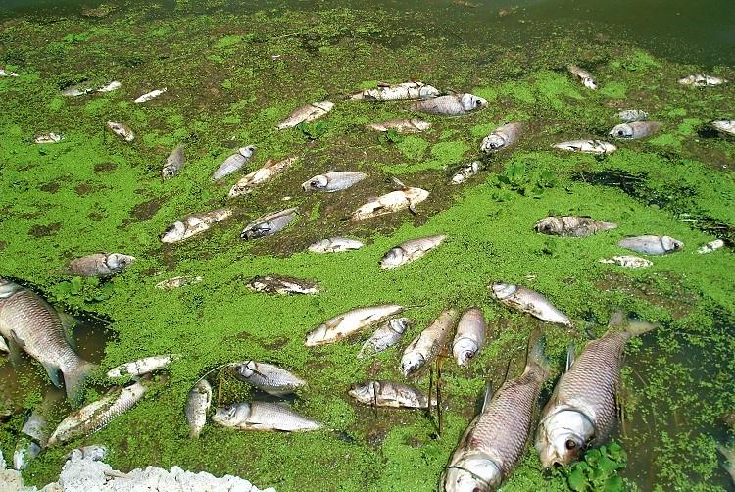

*Fig 2: Mass fish stock in Lake Victoria Shores impacted by the HABs (Image: Standard Media KE)*

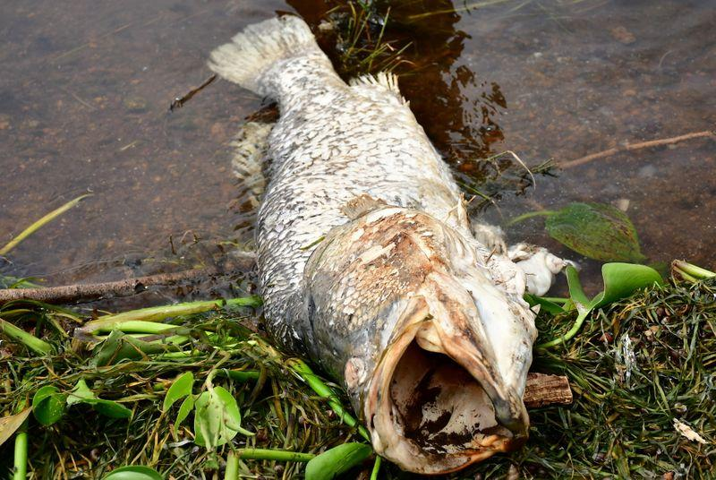

*Fig 3: High valued Fish lost to HAB in Lake Victoria Shores (Image Source: KMFRI)*

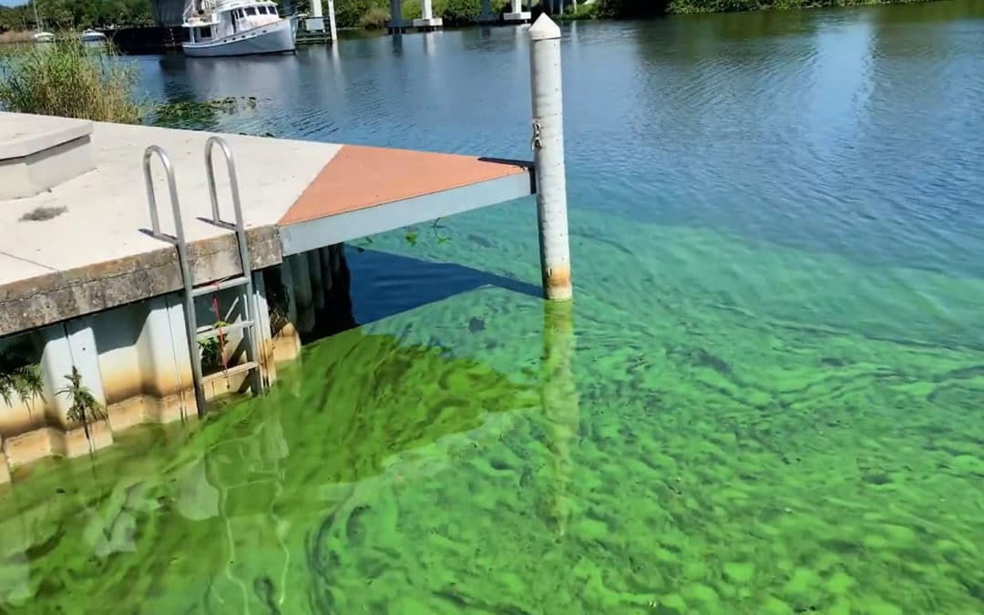

*Fig 4: Tourism and therefore Income halted to HABs*

## 1.3 Research identification and Objectives

The main objective of this research is to detect, monitor and report the occurrence of Harmful Algal Blooms (HABs) and Cyanobacteria in Lake Victoria. This is achievable through the following specific objectives:

### 1.3.1 Research objectives

1. To monitor chlorophyl-a(Chl-a) concentration & Cyanotoxins from L8 OLI data as HAB proxies in L. Victoria from 2015 to 2021.
2. To monitor Lake Surface Water Temperature (LSWT) from L8 TIRS images as another HAB indicator in L. Victoria.
3. To develop automated Internet of Things (IoT) *in situ* sensors, applicable in near real-time to monitor and report geo-tagged Water quality data (e.g., LSWT) from 2021 onwards.

### Research questions

The following questions are formulated with respect to aforementioned objectives:

1. Can space based observations systems be used to detect and monitor HABs in Lake Victoria Inland water body?
2. Does HAB occurrence have a direct impact on the LSWT at their point of influence?
3. Can IoT be utilized to monitor HAB occurrences inland water Lakes?

## 1.4 Study outline

This research study is intended to be divided into 6 chapters whereby the first chapter introduces the study by detailing into the background, motivation and problem statement, objectives and research questions; Chapter 2 will contain the reviewed literature and the research gaps identified and how this research intends to address the identified gaps. Further, Chapter 3 will show the data and methods used in the study with Chapter 4 highlighting the results for the findings from the methods. Chapter 5 will discuss on the findings and finally, Chapter 6 will conclude and recommend for future research that might not be addressed at this level of geoscientific expertise.

# 2. Literature review

# 3. Materials and methods

## 3.1 Study area

Lake Victoria, with a surface area of about 68,800 KM2 and an average depth of 40m at a maximum depth of 79m ranks the second largest fresh water lake in the world after Lake Superior and the Largest in Africa. Lying between 3o S to 0o 30`N latitude and 31o 40`E to 34o 50`E is distributed among these three East African countries viz Tanzania 51%, Uganda 43% and Kenya the remaining 6% (africangreatlakes.org).

That in place, the lake is privileged to serve as economical home of about 40 million residents (Calamari et al.,1995) in those riparian reserves. These millions of individuals solely bank on the lake for all aspects of their daily economic livelihood ranging from, fishing, agriculture, and industrial applications just to barely highlight but a few. On that regard, it’s ecological monitoring should be of great geoscientific interest.

Being located in Equatorial regions of the globe, the lake has an alternating climatic condition varying from tropical rain forest with rainfall over the lake for a better portion of the year to a semi dry climate with sporadically discontinuous droughts over some locations.

This provides ambient temperatures varying between 12-26°C which therefore provides an optimum host condition for the growth and development of the *Cyanobacteria spp.* in this scope (Okello et al., 2011).

Figure 5 shows the location and extent of the extract of the study area particularly relevant to this study.

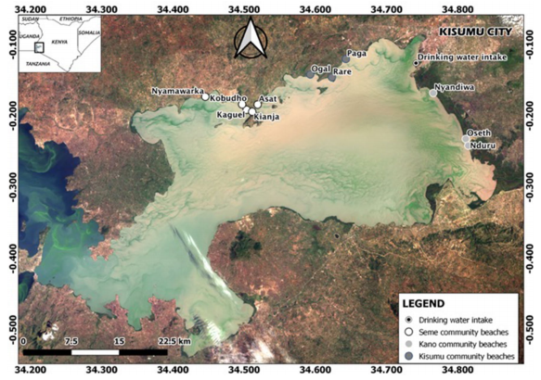**LAKE VICTORIA**

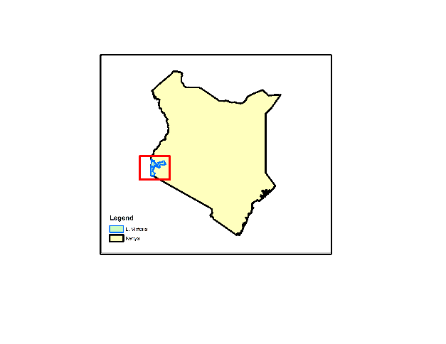

**NYANZA GULF**

Homabay

*Fig. 5 Remote-sensed image and map of Winam Gulf with study sites. Image was downloaded from www.glovi s.usgs.gov and a D0S1 atmospheric correction was performed in QGIS V3.0, with layer stacking of bands 2–7.*

## 3.2 Data

*Table 1: Data Sources and their roles*

|  |  |  |
| --- | --- | --- |
| Data Type | Source | Role/Use |
| Landsat 8 OLI  (30m, 16 days) | Google Earth Engine  (2015-2021) | Spatiotemporal HAB Monitoring |
| Landsat 8 TIR  (100m, 16 days) | Google Earth Engine  (2015-2021) | Lake Surface Water Temperature Monitoring (LSWT) |
| Meteorological Data | Kenya Marine & Fisheries Research Institute-KMFRI (2015-2021) | Water Quality assessment |
| Shapefiles | Geodatabase of Global Administrative areas- GADM | Delineate the Study area |
| In-Situ Data | In-situ Sensors 2021 Onwards | Continued In-Situ Algal Monitoring |

Table 2: Tools and Materials used in the study

|  |  |  |
| --- | --- | --- |
| **Tool/Material** | **Role** | **Availability** |
| **Google Earth Engine (GEE)** | **Geocomputation & Processing** | **Freely Available** |
| **QGIS, R & Python** | **Further Analysis & Maps** | **Free** |
| **Microcontroller & Sensors** | **In-Situ data Monitoring** | **Local Purchase** |
| **KiCAD** | **Design the Schematics & basic Circuits** | **Free & Open source** |

## 3.3 Methodology

*Fig 6: Overall Methodology Workflow for Objectives 1 and 2*

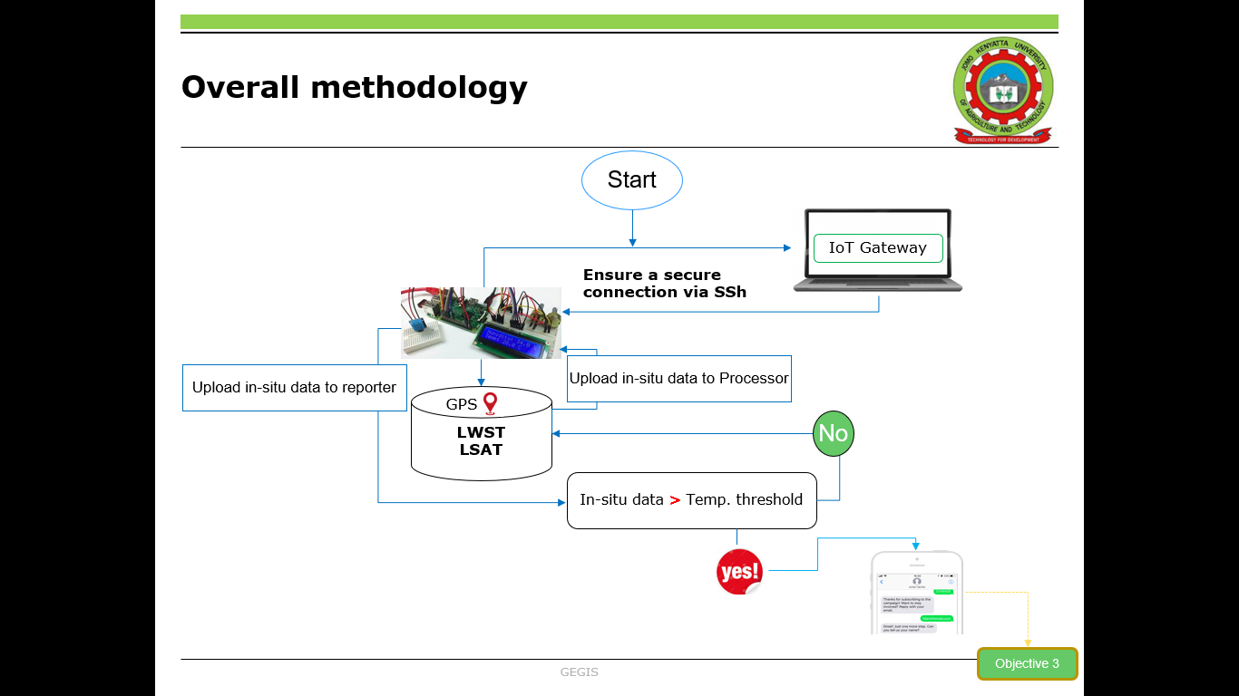*Fig 7: Overall Methodology Workflow for Objectives 3*

# 

# References

Allan, M. G., Hamilton, D. P., Hicks, B., and Brabyn, L. (2015). Empirical and semi-analytical chlorophyll-a algorithm for multi-temporal monitoring of New Zealand lakes using Landsat. Environ. Monit. Assess. 187, 364. https://doi:10. 1007/s10661-015-4585-4

Blondeau-Patissier, D., Gower, J. F. R., Dekker, A. G., Phinn, S. R., & Brando, V. E. (2014). *A review of ocean color remote sensing methods and statistical techniques for the detection, mapping and analysis of phytoplankton blooms in coastal and open oceans*. *Progress in Oceanography*, *123*, 123–144. <https://doi.org/10.1016/j.pocean.2013.12.008>

Calamari, D.; Akech, M.O.; Ochumba, P.B.O. (1995) *Pollution of Winam Gulf, Lake Victoria, Kenya: A case study for preliminary risk assessment*. Lakes Reserv. Res. Manag. 1, 89–106.

Gikuma-Njuru, P.; Hecky, R.E.; Guildford, S.J.; MacIntyre, S. (2013) *Spatial variability of nutrient concentrations, fluxes, and ecosystem metabolism in Nyanza Gulf and Rusinga Channel, Lake Victoria (East Africa)*. Limnol. Oceanogr.58, 774–789.

Gitelson, A. (1992). The peak near 700 nm on radiance spectra of algae and water: relationships of its magnitude and position with chlorophyll concentration. Int. J. Rem. Sens. 13, 3367–3373. doi:10.1080/ 01431169208904125

Gohin F. et al., (2003) “Satellite and in situ observations of a late winter phytoplankton bloom, in the Northern Bay of Biscay.” Continental Shelf Research, vol. 23, pp. 1117–1141,

Hecky, R. E., Mugidde, R., Ramlal, P. S., Talbot, M. R., & Kling, G. W. (2010). Multiple stressors cause rapid ecosystem change in Lake Victoria. Freshwater Biology, 55, 19–42. <https://doi.org/10.1111/j.1365-2427.2009.02374.x>

Hill, P. R., Kumar, A., Temimi, M., & Bull, D. R. (2020). HABNet: Machine Learning, Remote Sensing Based Detection and Prediction of Harmful Algal Blooms. ArXiv:1912.02305 [Cs, Eess]. <http://arxiv.org/abs/1912.02305>

Khalili, M. H., & Hasanlou, M. (2019). HARMFUL ALGAL BLOOMS MONITORING USING SENTINEL-2 SATELLITE IMAGES. The International Archives of the Photogrammetry, Remote Sensing and Spatial Information Sciences, XLII-4/W18, 609–613. <https://doi.org/10.5194/isprs-archives-XLII-4-W18-609-2019>

Kurekin, A.A., Miller, P.I., Van der Woerd, H.J., (2014). *Satellite discrimination of Karenia mikimotoi and Phaeocystis harmful algal blooms in European coastal waters: merged classification of ocean colour data*. Harmful Algae 31, 163–176

Mittenzwey, K. H., Ullrich, S., Gitelson, A., and Kondratiev, K. (1992). *Determination of chlorophyll a of inland waters on the basis of spectral reflectance*. Limnol. Oceanogr. 37, 147–149. [*https://doi:10.4319/lo.1992.37.1.0147*](https://doi:10.4319/lo.1992.37.1.0147)

Okello, W., & Kurmayer, R. (2011)*. Seasonal development of cyanobacteria and microcystin production in Ugandan freshwater lakes: Seasonal development of cyanobacteria and microcystin production. Lakes & Reservoirs: Research & Management,* 16(2), 123–135. <https://doi.org/10.1111/j.1440-1770.2011.00450.x>

O’Reilly, J. E., Maritorena, S., Mitchell, B. G., Siegel, D. A., Carder, K. L., Garver, S. A., et al. (1998). Ocean color chlorophyll algorithms for SeaWiFS. J. Geophys. Res. 103, 24937–24953. <https://doi:10.1029/98jc02160>

Richardson, K., 1997. Harmful or exceptional phytoplankton blooms in the marine ecosystem. Advances in Marine Biology 31, 301–385

Santoleri R. et al., “Year-to-year variability of the phytoplankton bloom in the southern adriatic sea (1998-2000): sea-viewing wide field-of-view sensor observations and modeling study,” Journal of Geophysical Research, vol. 108, p. 8122, 2003

Simiyu, B., Oduor, S., Rohrlack, T., Sitoki, L., & Kurmayer, R. (2018). Microcystin Content in Phytoplankton and in Small Fish from Eutrophic Nyanza Gulf, Lake Victoria, Kenya. Toxins, 10(7), 275. <https://doi.org/10.3390/toxins10070275>

Smith, R. B., Bass, B., Sawyer, D., Depew, D., & Watson, S. B. (2019). Estimating the economic costs of algal blooms in the Canadian Lake Erie Basin. Harmful Algae, 87, 101624. <https://doi.org/10.1016/j.hal.2019.101624>

Sitoki, L.; Kurmayer, R.; Rott, E(2012). Spatial variation of phytoplankton composition, biovolume, and resulting microcystin concentrations in the Nyanza Gulf (Lake Victoria, Kenya). Hydrobiologia, 691, 109–122.

Song, W., Dolan, J., Cline, D., & Xiong, G. (2015). Learning-Based Algal Bloom Event Recognition for Oceanographic Decision Support System Using Remote Sensing Data. Remote Sensing, 7(10), 13564–13585. <https://doi.org/10.3390/rs71013564>

Tamatamah, R. A., Hecky, R. E., & Duthie, HamishC. (2005). *The atmospheric deposition of phosphorus in Lake Victoria (East Africa)*. Biogeochemistry, 73(2), 325–344. <https://doi.org/10.1007/s10533-004-0196-9>

Tang, D., Kawamura, H., Oh, I. S., & Baker, J. (2006). *Satellite evidence of harmful algal blooms and related oceanographic features in the Bohai Sea during autumn 1998*. Advances in Space Research, 9.

Watanabe, F. S., Alcantara, E., Rodrigues, T. W., Imai, N. N., Barbosa, C. C., and Rotta, L. H. (2015). *Estimation of chlorophyll-a concentration and the trophic state of the Barra Bonita hydroelectric reservoir using OLI/ Landsat-8 images.* Int. J. Environ. Res. Publ. Health 12, 10391–10417. doi:10.3390/ijerph120910391

W. Song, J.M Dola, D. Cline and G. Xiong. (2015). Learning-based algal bloom event recognition for oceanographic decision support system using remote sensing data, Remote Sensing, vol. 7, no. 10, pp. 13 564–13 585.

# Appendix

Add any extra materials that could not fit in the main text of your write up and is relevant to your study.

Lorem ipsum dolor sit amet, consectetuer adipiscing elit. Maecenas porttitor congue massa. Fusce posuere, magna sed pulvinar ultricies, purus lectus malesuada libero, sit amet commodo magna eros quis urna. Nunc viverra imperdiet enim. Fusce est. Vivamus a tellus. Pellentesque habitant morbi tristique senectus et netus et malesuada fames ac turpis egestas. Proin pharetra nonummy pede. Mauris et orci. Aenean nec lorem.

In porttitor. Donec laoreet nonummy augue. Suspendisse dui purus, scelerisque at, vulputate vitae, pretium mattis, nunc. Mauris eget neque at sem venenatis eleifend. Ut nonummy. Fusce aliquet pede non pede. Suspendisse dapibus lorem pellentesque magna. Integer nulla. Donec blandit feugiat ligula. Donec hendrerit, felis et imperdiet euismod, purus ipsum pretium metus, in lacinia nulla nisl eget sapien.

Donec ut est in lectus consequat consequat. Etiam eget dui. Aliquam erat volutpat. Sed at lorem in nunc porta tristique. Proin nec augue. Quisque aliquam tempor magna. Pellentesque habitant morbi tristique senectus et netus et malesuada fames ac turpis egestas. Nunc ac magna. Maecenas odio dolor, vulputate vel, auctor ac, accumsan id, felis. Pellentesque cursus sagittis felis.